Published on The National Interest (http://nationalinterest.org)
Home > Why Is Trump Abandoning the Foreign Policy that Brought Him Victory?

Why Is Trump Abandoning the Foreign Policy that Brought Him Victory?

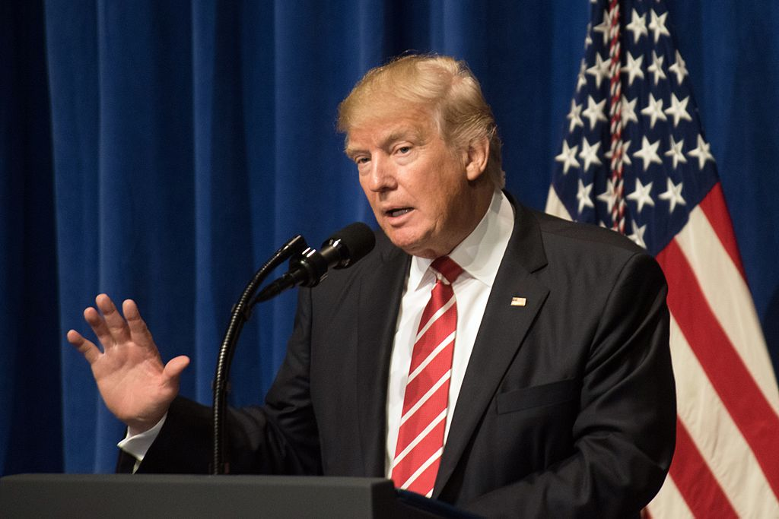
The American people, having voted against the promiscuous military intervention of Trump’s predecessors, may well end up with more of the same foreign policy.
Doug Bandow [2]
Candidate Donald Trump offered a sharp break from his predecessors. He was particularly critical of neoconservatives, who seemed to back war at every turn.
Indeed, he promised not to include in his administration “those who have perfect resumes but very little to brag about except responsibility for a long history of failed policies and continued losses at war.” And he’s generally kept that commitment, for instance rejecting as deputy secretary of state Elliot Abrams, who said Trump was unfit to be president.
Substantively candidate Trump appeared to offer not so much a philosophy as an inclination. Practical if not exactly realist, he cared more for consequences than his three immediate predecessors, who had treated wars as moral crusades in Somalia, the Balkans, Afghanistan, Iraq, Libya and Syria. In contrast, Trump promised: “unlike other candidates for the presidency, war and aggression will not be my first instinct.”
Yet so far the Trump administration is shaping up as a disappointment for those who hoped for a break from the liberal interventionist/neoconservative synthesis.
The first problem is staffing. In Washington people are policy. The president can speak and tweet, but he needs others to turn ideas into reality and implement his directives. It doesn’t appear that he has any foreign policy realists around him, or anyone with a restrained view of America’s international responsibilities.
Rex Tillerson, James Mattis and H. R. McMaster are all serious and talented, and none are neocons. But all seem inclined toward traditional foreign policy approaches and committed to moderating their boss’s unconventional thoughts. Most of the names mentioned for deputy secretary of state have been reliably hawkish, or some combination of hawk and centrist—Abrams, John Bolton, the rewired Jon Huntsman.
Trump appears to be most concerned with issues that have direct domestic impacts, and especially with economic nostrums about which he is most obviously wrong. He’s long been a protectionist (his anti-immigration opinions are of more recent vintage). Yet his views have not changed even as circumstances have. The Chinese once artificially limited the value of the renminbi, but recently have taken the opposite approach. The United States is not alone in losing manufacturing jobs, which are disappearing around the world and won’t be coming back. Multilateral trade agreements are rarely perfect, but they are not zero sum games. They usually offer political as well as economic benefits. Trump does not seem prepared to acknowledge this, at least rhetorically. Indeed he has brought on board virulent opponents of free trade such as Peter Navarro.
The administration’s repudiation of the Trans-Pacific Partnership was particularly damaging. Trump’s decision embarrassed Japanese prime minister Shinzo Abe, who had offered important economic concessions to join. More important, Trump has abandoned the economic field to the People’s Republic of China, which is pushing two different accords. Australia, among other U.S. allies, has indicated that it now will deal with Beijing, which gets to set the Pacific trade agenda. In this instance, what’s good for China is bad for the United States.
In contrast, on more abstract foreign policy issues President Trump seems ready to treat minor concessions as major victories and move on. For years he criticized America’s Asian and European allies for taking advantage of U.S. defense generosity. In his March foreign policy speech, he complained that “our allies are not paying their fair share.” During the campaign he suggested refusing to honor NATO’s Article 5 commitment and leave countries failing to make sufficient financial contributions to their fate.
Yet Secretaries Mattis and Tillerson have insisted that Washington remains committed to the very same alliances incorporating dependence on America. Worse, in his speech to Congress the president took credit for the small uptick in military outlays by European NATO members which actually began in 2015: “based on our very strong and frank discussions, they are beginning” to “meet their financial obligations.” Although he declared with predictable exaggeration that “the money is pouring in,” no one believes that Germany, which will go from 1.19 to 1.22 percent of GDP this year, will nearly double its outlays to hit even the NATO standard of two percent.
Trump’s signature policy initiative, rapprochement with Russia, appears dead in the water. Unfortunately, the president’s strange personal enthusiasm for Vladimir Putin undercut his desire to accommodate a great power which has no fundamental, irresolvable conflicts with the America. Contrary to neocon history, Russia and America have often cooperated in the past. Moreover, President Trump’s attempt to improve relations faces strong ideological opposition from neoconservatives determined to have a new enemy and partisan resistance from liberal Democrats committed to undermining the new administration.
President Trump also appears to have no appointees who share his commitment on this issue. At least Trump’s first National Security Adviser, Mike Flynn, wanted better relations with Russia, amid other, more dubious beliefs, but now the president seems alone. In fact, Secretary Tillerson sounded like he was representing the Obama administration when he demanded Moscow’s withdrawal from Crimea, a policy nonstarter. Ambassador-designate Huntsman’s views are unclear, but he will be constrained by the State Department bureaucracy, which is at best unimaginative and at worst actively obstructionist.
The president appears to be heading in the opposite direction regarding China. How best to handle America’s one potential peer competitor is a matter of serious debate, but even before taking office President Trump launched what appeared to be confrontation on multiple fronts: Taiwan, trade, South China Sea, North Korea. Secretary Tillerson again took a highly adversarial position, suggesting in Senate testimony that the United States might blockade the PRC’s claimed Pacific possessions, a casus belli, and “compel,” whatever that means, compliance with sanctions against North Korea. Here the administration is playing with fire. Whether the administration will set priorities and take a more balanced approach as more seasoned Asia experts are appointed is yet to be seen.
Trump policy in the Middle East seems in confused flux. During the campaign he briefly pushed an “even-handed” approach to Israel and the Palestinians, before going all in backing the hardline Likud government’s practical repudiation of a two-state solution and expanded colonization of the West Bank. Since then, however, he, like other presidents before him, has backed away—though perhaps only temporarily—from the promise to move the U.S. embassy to Jerusalem. Moreover, President Trump has emphasized his desire to make a peace deal, which obviously would require concessions on both sides.
The president appears to be stepping into the Syrian and Iraq quagmires despite his election promises to the contrary. He sharply criticized previous policy in the Mideast: “Logic replaced with foolishness and arrogance, which led to one foreign policy disaster after another.” He explicitly denounced interventions in Iraq and Libya, promising to get out “of the nation-building business,” and emphasized the defeat of the Islamic State rather than overthrow of Bashar al-Assad.
Yet the administration just introduced a Marine Corps artillery battalion and other forces to assist in capturing the ISIS capital of Raqqa, Syria. Despite complaining about inadequate burden-sharing principle in the Middle East, President Trump risks encouraging the Gulf States and Turkey to reduce their efforts to defeat the Islamic State. As president he also proposed creating “safe zones” in Syria, which would require an extensive and potentially long-term U.S. military presence. There are reports that the administration is considering an extended military role in Iraq as well.
Finally, the president appears to have reversed himself on Afghanistan. Early in the campaign he said America should end its longest war, which has devolved into a forlorn attempt to create a centralized, liberal democratic state in Central Asia. More recently, however, he indicated he planned to keep U.S. forces there. In December he told Afghan president Ashraf Ghani that he “would certainly continue to support Afghanistan security.” There may be no conflict which less advances serious American interests than attempting to sustain an incompetent, corrupt and failing central government in Kabul.
Where the president stands on other issues is unclear. His support for Brexit has roiled relations with Europe, which also worries about his protectionist beliefs—highlighted by his attack on Germany’s alleged currency manipulation—and potentially softer approach to Russia. Despite being highly critical of the Iran nuclear accord, he has not yet challenged the pact. He appears to be restoring Washington’s uncritical embrace of Saudi Arabia, which will undermine his expressed desire for greater burden-sharing by allies and yield long-term problems in Yemen. The administrations seems to have dropped more bombs in Yemen in the past week than the Obama administration did in the past year. At the same time, Trump has barely noticed Africa and South America. China has been steadily expanding its economic influence in both regions. How does Trump propose to maintain American interests in those regions? So far, he has offered nothing but silence.
It remains early for the Trump administration, and there’s no there there in much of the State and Defense departments, as well as other agencies. The president still could move in a more pragmatic, realist direction. However, without allies in his administration that prospect seems small. What Hegel called the “cunning of history” appears to be at work once again. The American people, having voted against the promiscuous military intervention of Trump’s predecessors, may well end up with more of the same foreign policy.
Doug Bandow is a Senior Fellow at the Cato Institute and a former Special Assistant to President Ronald Reagan. He is the author of Foreign Follies: America’s New Global Empire [3].
Image [4]: Donald Trump at MacDill Air Force Base. Wikimedia Commons/Public domain
Tags
Donald Trump [5]realism [6]Afghanistan [7]Neoconservatives [8]Interventionism [9]
Topics
Politics [10]
Regions
Americas [11]

Source URL (retrieved on March 18, 2017): http://nationalinterest.org/blog/the-skeptics/why-trump-abandoning-the-foreign-policy-brought-him-victory-19738
Links:
[1] http://nationalinterest.org/blog/the-skeptics/why-trump-abandoning-the-foreign-policy-brought-him-victory-19738
[2] http://nationalinterest.org/profile/doug-bandow
[3] http://amzn.to/2mJh8Nn
[4] https://commons.wikimedia.org/wiki/File:Trump_visits_MacDill_Air_Force_Base_(31942365443).jpg
[5] http://nationalinterest.org/tag/donald-trump
[6] http://nationalinterest.org/tag/realism
[7] http://nationalinterest.org/tag/afghanistan
[8] http://nationalinterest.org/tag/neoconservatives
[9] http://nationalinterest.org/tag/interventionism
[10] http://nationalinterest.org/topic/politics
[11] http://nationalinterest.org/region/americas

Note: A reader comment critical of author Doug Bandow refers us to this OP-ED Articles For Sale article.
“For years, rumors have swirled of an underground opinion "pay-for-play" industry in Washington in which think-tank employees and pundits trade their ability to shape public perception for cash.”

